Ideal jobs for our group are

Benjamin King: Cyber Warfare Officer

Douglas Baker: Systems & Network Engineer

Morgan Cassar: Cyber Security Manager

Ryan Williams: Senior Software Engineer

Robbie Cross: Chief Technical Officer

Ty Lynch: Senior C++ Engineer

The Burning Glass Top Occupations data set was used to rank each job titles

Roberts job title was not directly included in the data as such he has been considered as a Computer Systems Engineer for this task

1. Ryan Willaims and Ty Lynch
2. Robert Cross
3. Douglas Barker
4. Benjamin King and Morgan Cessar

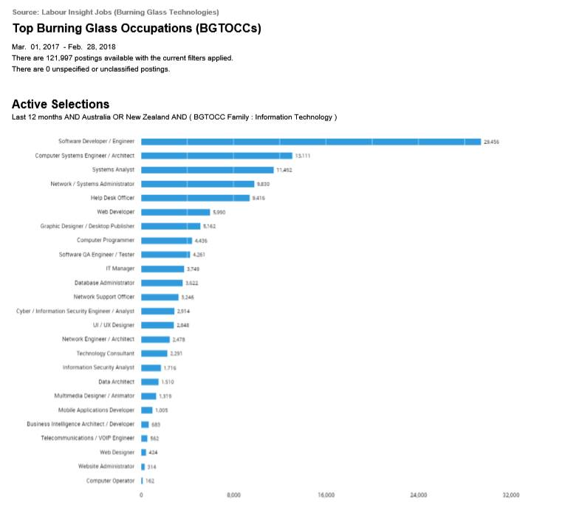

The skillset we have identified from the ideal jobs in assignment one has been divided into to two skill categories General and IT-specific these are as follows:

General

* Teamwork
* Communication Skills
* Leadership
* Team Management
* Organisational skills
* Problem Solving
* Troubleshooting
* Planning
* Meeting Deadlines
* Presentation Skills
* Writing
* Research
* English
* Business Management

IT-specific

* Java
* JavaScript
* Python
* Postgres (SQL)
* Oracle
* Windows
* Linux
* Databases
* System Design
* Systems Engineering
* Software Engineering
* Technical support
* Project Management
* Customer Service

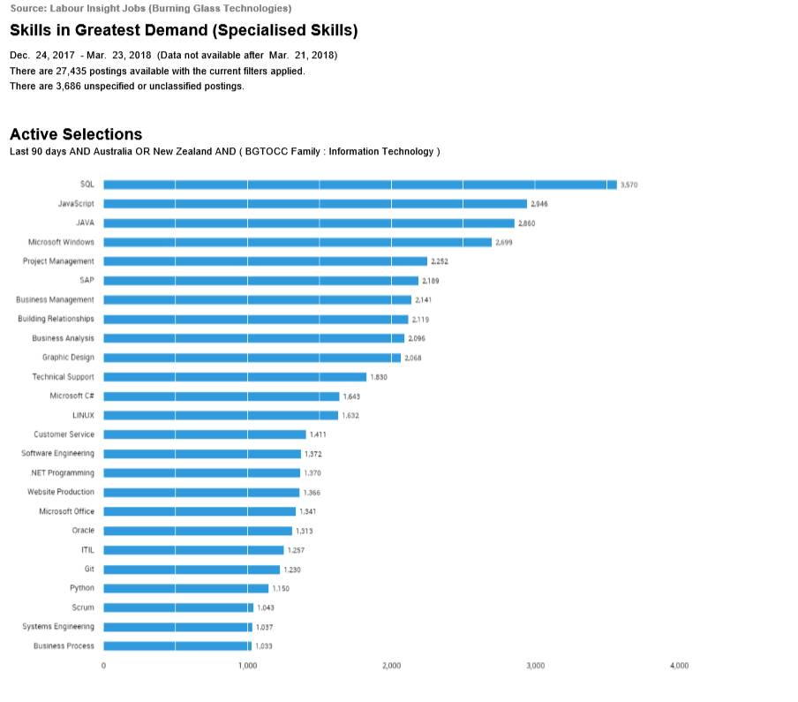

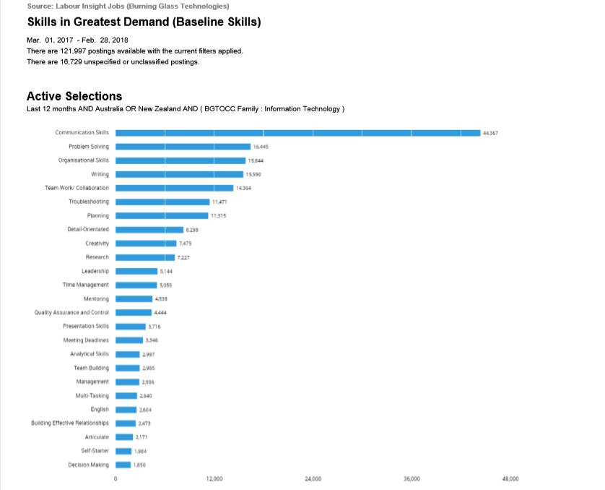

We think the skills our team members possess rank quite well in IT-specific skills when comparing to the data. Our team covers the top 5 skills and cover over half the skills in greatest demand. We are a very well rounded group and because of this, we would be able to tackle a varied range of projects in a variety of different programming languages.

The team meets the top 6 highest-ranking skills in the general skills category we meet half the required skills in this category. With all team members requiring teamwork and communication skills we think we would make a great team.

The three highest-ranked IT-specific skills our team is missing are:

* SAP
* Building relationships
* Graphic Design

The three highest-ranked general skills that our team is missing are:

* Detail-Orientated
* Creativity
* Mentoring

• Having looked at the Burning Glass data, has your opinion of your ideal job changed? Why or why not?

Benjamin King:

Ryan Williams:

Morgan Cassar:  
  
After looking at the burning glass data, I think I would still be interested in the job I researched in Assignment 1. It uses a lot of highly ranked general skills, such as communication skills and writing. It does not however rank as highly in IT-specific skills, with skills in Microsoft Windows being the only high ranked skill. Due to the nature of the job, cyber security, I do believe that it is an important field and that jobs will be in demand. It could however leave me out of the IT side of the industry as it only requires high levels of Microsoft Windows knowledge but leaves out a lot of other IT-specific skills. Pursuing this career, although may have lots of opportunities, it might stop me from branching out into a more IT-Specific job.

Robert Cross:

Douglas Barker:

Ty Lynch:

From analyzing the burning glass data I think my opinion has changed about the job that I would like to pursue. This is because the job I used in assignment 1 does not require the knowledge in most of the categories listed and the few that is does rank quite poorly in the IT-specific field. It also requires hardly any skills in the general category although some skill may possibly be used that had not been listed in the advertisement. Following this career path may leave me in a niche industry while is specialized and a passion to work with games, it may close the door to other opportunities in the future leave me stranded in that type of work as it would be possibly difficult to branch out to another sector of the IT industry.

*References:*

1. [*https://rmit.instructure.com/courses/70682/files/10954610/download*](https://rmit.instructure.com/courses/70682/files/10954610/download?wrap=1)
2. [*https://rmit.instructure.com/courses/70682/files/10954543/download*](https://rmit.instructure.com/courses/70682/files/10954543/download?wrap=1)
3. [*https://rmit.instructure.com/courses/70682/files/10954568/download*](https://rmit.instructure.com/courses/70682/files/10954568/download?wrap=1)

*Notes (Do not include in the final report):*

*While your job may require more skills I’ve only taken the ones listed from your*

*Job description apart from Douglas with you I had a rough guess based on what you had written on your assignment 1*

*Ty software engineering python system design C++*

*Teamwork communication skills*

*Ryan java, databases, software engineering, oracle, customer service, Postgres (SQL),*

*Communication skills, planning*

*Robert Javascript, java, customer service, project management, Business management*

*Communication skills, teamwork, leadership, organizational skills, team management, decision making, presentation skills, meeting deadlines*

*Douglas technical support, systems engineering,*

*Teamwork communications skills, troubleshooting leadership, problem-solving*

*Benjamin windows, Linux, programming languages various*

*Leadership, teamwork, communication skills, research*

*Morgan systems engineering, windows,*

*Leadership, teamwork, communication skills, planning, writing*